**PART 1: FOLDER TREE**

**PART 2: INSIDE A SNIP CODE**

## **Introduction to Clean Code**

Clean code refers to the art of writing code that is easy to **understand, simple, and free of any ambiguity**. It is like writing a well-structured essay where each line of code conveys its purpose clearly. Clean code follows certain principles and best practices that make it easier for other developers to collaborate, maintain, and extend the codebase.

### **Importance of Clean Code**

* **Enhances the readability** of the codebase, making it easier for developers to understand the logic and flow of the program.
* **Reduces the chances of introducing bugs and errors**, thus improving the overall quality of the software.
* **Promotes good coding habits** and fosters a sense of pride and ownership among developers.

### **Benefits of Writing Clean Code**

The benefits of writing clean code **are manifold**. It leads to better **maintainability, easier debugging, faster development, and improved collaboration among team members**. Clean code also results in fewer bugs, reduced technical debt, and increased efficiency in the long run.

## **Principles of Clean Code**

### **Names**

One of the fundamental principles of clean code is using meaningful and descriptive names for variables, functions, classes, and methods. Meaningful names make the code self-explanatory and reduce the need for excessive comments.

### **Functions**

Functions should be small, focused, and do one thing well. They should have a clear purpose and follow the Single Responsibility Principle (SRP). Avoid long and complex functions that perform multiple tasks.

### **Comments**

While clean code should be self-explanatory, there are times when comments are necessary to clarify the intent behind certain code snippets. Comments should be concise, relevant, and add value to the codebase.

### **Formatting**

Consistent formatting is essential for clean code. Use proper indentation, spacing, and naming conventions to enhance readability. Tools like Black and PEP 8 can help in maintaining consistent code formatting.

### **Error Handling**

Proper error handling is crucial for writing clean code. Always anticipate and handle exceptions gracefully to prevent crashes and unexpected behavior in your program.

## **Clean Code Best Practices**

### **Single Responsibility Principle**

The Single Responsibility Principle states that a function or class should have only one reason to change. By adhering to this principle, you can create modular and maintainable code that is easier to test and debug.

### **Avoid Magic Numbers**

Magic numbers are hard-coded constants that lack context and make the code difficult to understand. Instead of using magic numbers, define constants with descriptive names to improve code readability and maintainability.

### **Don't Repeat Yourself (DRY)**

The DRY principle emphasizes the importance of code reusability. Avoid duplicating code by extracting common functionality into separate functions or classes. This not only reduces redundancy but also makes the codebase more maintainable.

In short, under DRY principle, every piece of knowledge must have a single, unambiguous, authoritative representation writing a system. Software repetition of the same information (same code produced multiple times). Having the same code in multiple places makes maintainability much harder, as the changes need to be done in all occurrences. Achieving DRY can be done by diving code into smaller pieces of functionality, which can be reused easily. DRY violations are called WET (Write Everything Twice / We Enjoy Typing).

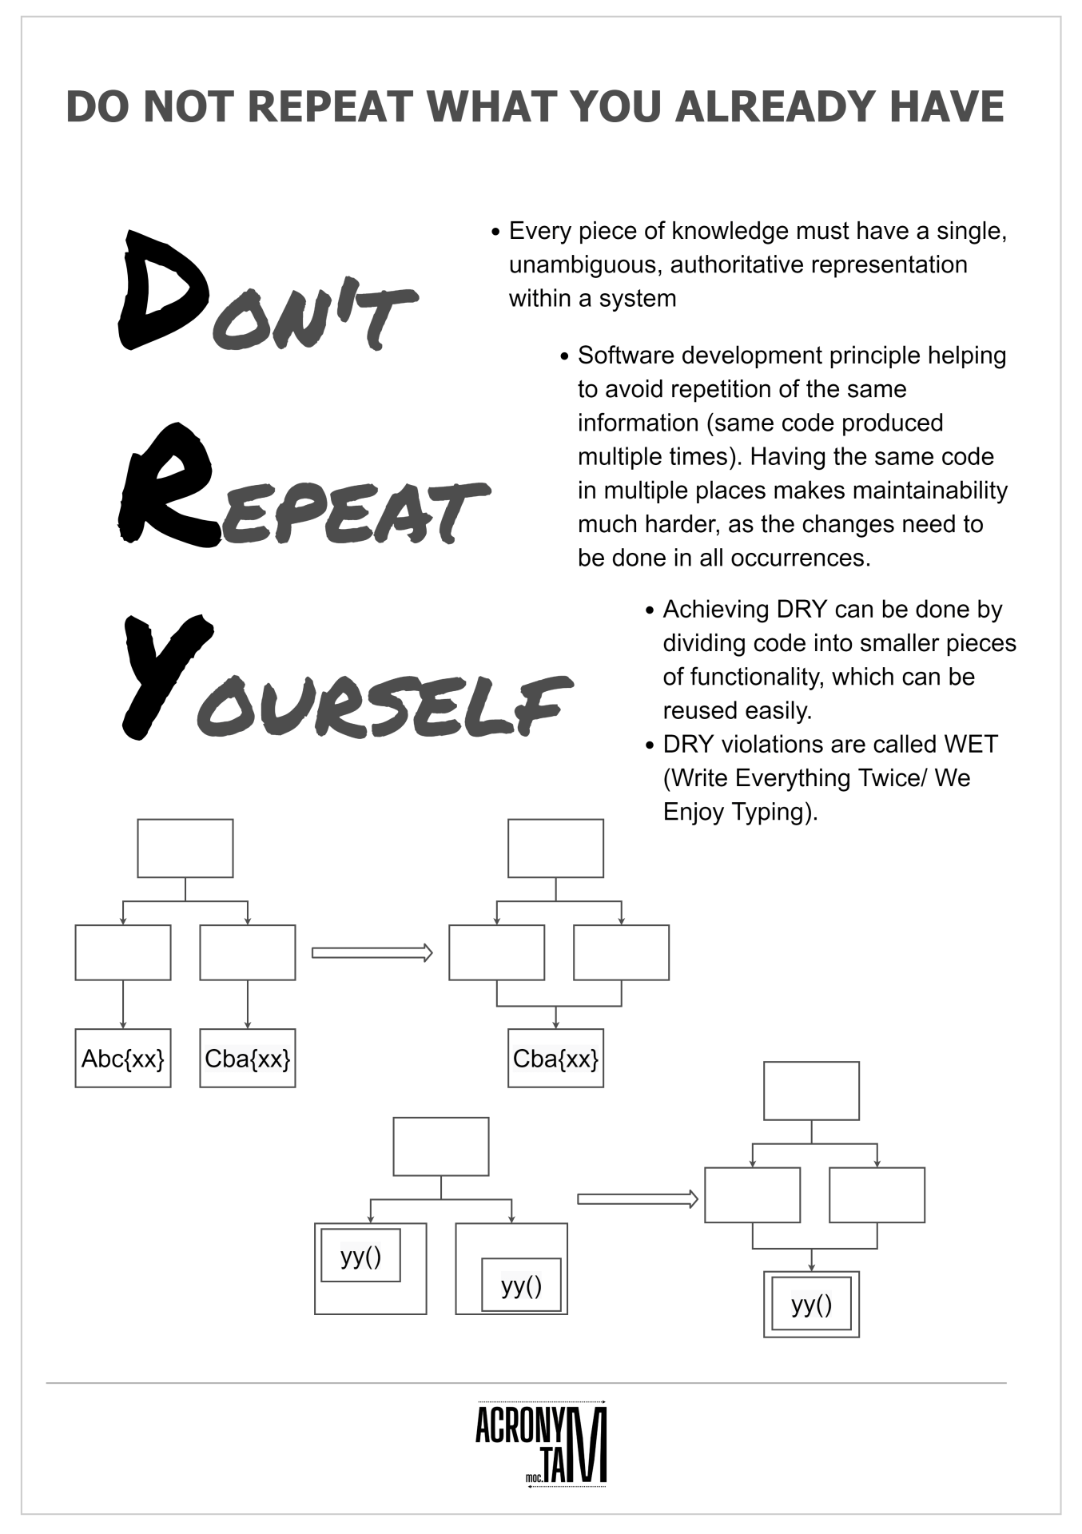

**Example:**

**WET CODE**

In the WET code example, the calculation and output logic for calculating the area and circumference of a circle are duplicated in two separate functions. This violates the DRY principle since the code for the calculations is repeated.

In the below DRY code example, the calculation logic is extracted into separate functions (calculate_circle_area and calculate_circle_ circumference), which can be reused. The print_circle_properties function then calls these calculation functions and handles the output logic. This approach eliminates code duplication and follows the DRY principle.

By adhering to the DRY principle, the code becomes more maintainable, as any changes or updates to the calculation logic only need to be made in one place.

**DRY CODE**

**Steps to be done for DRY CODE**

* Group reusable code together: Identify portions of your code that can be reused across multiple places and group them together. This can be achieved by creating functions or classes that encapsulate the common functionality. By doing so, you avoid duplicating code and promote code reusability.
* Name these groups logically: Give meaningful and descriptive names to your functions, classes, or modules that represent the groups of reusable code. The names should reflect the purpose or functionality of the group. This helps in understanding the code and its intended usage.
* Add your code to the various code groups: Once you have grouped the reusable code and named them appropriately, you can then use those functions, classes, or modules in different parts of your Python codebase. By utilizing these grouped components, you ensure that the shared functionality is applied consistently and efficiently wherever needed.

Here's an example to illustrate these concepts:

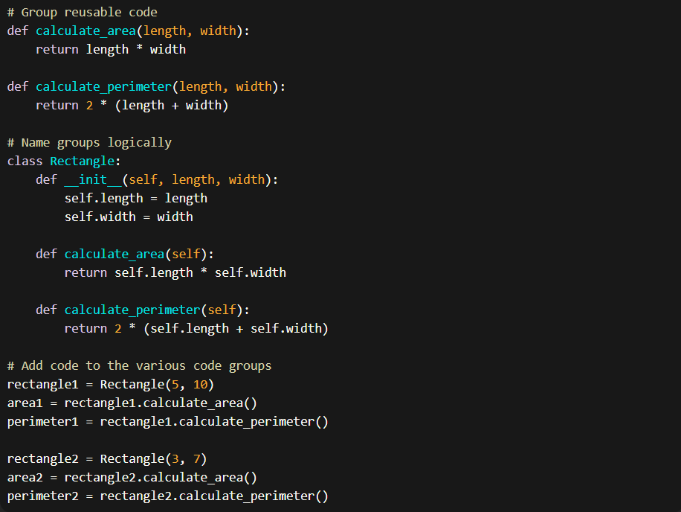

In this example, the code related to calculating the area and perimeter of a rectangle is grouped together in the calculate_area and calculate_perimeter functions. The functionality is encapsulated within the Rectangle class, which can be instantiated to create different rectangle objects. The code is then used to calculate the area and perimeter of specific rectangles (rectangle1 and rectangle2) by invoking the appropriate methods.

By applying these principles, you can reduce code duplication, promote reusability, and improve the maintainability of your Python code.

### **You Ain't Gonna Need It (YAGNI)**

The YAGNI (You Ain't Gonna Need It) principle is a guiding principle in software development that suggests not to implement functionality or add features until they are actually needed. It encourages developers to avoid speculation about future requirements and instead focus on the current needs of the software.

The key idea behind the YAGNI principle is to prevent unnecessary complexity, over-engineering, and wasted effort. By only implementing what is necessary at the present moment, developers can avoid spending time and resources on features that may never be used or may change significantly in the future.

The YAGNI principle promotes simplicity and agility in software development. It encourages developers to write code that solves the immediate problem at hand and postpones the implementation of additional features until they are deemed necessary based on real requirements or user feedback.

Applying the YAGNI principle can lead to more maintainable and flexible codebases. It helps prevent feature bloat, reduces unnecessary dependencies, and allows for easier refactoring and adaptation to changing requirements.

However, it's important to strike a balance between applying the YAGNI principle and anticipating potential future needs. It's not about rejecting all potential requirements but rather about avoiding premature optimization and excessive complexity. It's a reminder to stay focused on delivering value and continuously evaluate the necessity of adding new features.

### **Keep It Simple, Stupid (KISS)**

The KISS principle advocates for simplicity in design and implementation. Write code that is straightforward, easy to understand, and avoids unnecessary complexity. Simple code is easier to maintain and less prone to errors.

The KISS (Keep It Simple, Stupid) principle is a design principle in software development that emphasizes the importance of simplicity and avoiding unnecessary complexity. The principle suggests that systems and solutions should be kept as simple as possible while still meeting the required functionality.

The core idea behind the KISS principle is that simplicity leads to better maintainability, readability, and overall understanding of the code. By keeping things simple, developers can reduce the likelihood of bugs, improve code comprehensibility, and make it easier for others to collaborate on and maintain the codebase.

Here are some key aspects of the KISS principle:

* Simplicity: Strive for simplicity in code design and implementation. Avoid over-engineering and unnecessary complexity.
* Clear and Readable Code: Write code that is easy to read, understand, and follow. Use descriptive names for variables, functions, and classes. Break down complex tasks into smaller, more manageable parts.
* Minimal Dependencies: Minimize dependencies between components or modules. Reduce coupling and strive for loose coupling between different parts of the system.
* Avoid Over-Optimization: Don't over-optimize code prematurely. Focus on solving the immediate problem and optimize later if and when necessary.
* Regular Refactoring: Continuously review and refactor code to simplify it and remove any unnecessary complexity that may have crept in over time.

The KISS principle encourages developers to prioritize simplicity and clarity over unnecessary sophistication. It promotes a pragmatic approach to software development, where the goal is to create solutions that are easy to understand, maintain, and modify.

### **Simple is not easy (SINE)**

The concept of "SINE" (Simple is not easy) is a perspective that acknowledges the distinction between simplicity and the effort required to achieve it. While simplicity is often desirable in software development, it's not always easy to achieve due to various factors such as complex requirements, technical constraints, and evolving project dynamics.

"SINE" highlights the fact that simplicity is a goal that requires intentional effort, thoughtful design, and careful decision-making. It recognizes that achieving simplicity can be a challenging and iterative process, sometimes requiring trade-offs and compromises along the way.

Here are some key points related to the "SINE" concept:

Intentional Design: Simplicity doesn't happen by chance. It requires deliberate design decisions and a conscious effort to remove unnecessary complexity from the system.

Iterative Refinement: Simplicity often emerges through an iterative process of refinement. It may involve continuously evaluating and simplifying the codebase, architecture, and overall design based on feedback and evolving requirements.

Complexity Trade-offs: Achieving simplicity may involve making trade-offs and decisions about what features or capabilities to prioritize and what to exclude. It's about finding the right balance between simplicity and meeting the necessary requirements.

Communication and Collaboration: Simplicity is not just about the code; it also extends to communication and collaboration within the development team. Clear communication and collaboration can help align everyone's understanding and contribute to simpler and more effective solutions.

Continuous Improvement: Simplicity should be viewed as an ongoing pursuit. It's not a one-time effort but rather a mindset that encourages constant evaluation, refinement, and improvement.

### **CHAPTER OVERVIEW**

## **Tools for Writing Clean Code**

There are several tools available that can help you write clean code in Python:

### **Linters**

Linters such as Flake8 and Pylint analyze your code for potential errors, style violations, and code smells. They provide suggestions for improving code quality and adherence to best practices.

### **Code Formatters**

Code formatters like Black automatically format your code according to a predefined style guide. They ensure consistent code formatting across your project and help in maintaining clean and readable code.

### **IDEs**

Integrated Development Environments (IDEs) like PyCharm and VS Code offer features such as code completion, refactoring tools, and debugging capabilities that aid in writing clean and efficient code.

## **Common Mistakes to Avoid**

When writing clean code, avoid common mistakes such as using cryptic variable names, neglecting proper documentation, ignoring code reviews, and not following coding standards. By being aware of these pitfalls, you can improve the quality of your codebase.

## **Refactoring and Code Reviews**

Refactoring is the process of restructuring existing code without changing its external behavior. It helps in improving code quality, readability, and maintainability. Code reviews, on the other hand, involve peer evaluation of code changes to ensure adherence to coding standards and best practices.

## **Testing and Clean Code**

Testing is an integral part of writing clean code. By writing unit tests, integration tests, and end-to-end tests, you can ensure that your code functions as intended and remains robust in the face of changes. Test-driven development (TDD) is a methodology that emphasizes writing tests before writing the actual code.

## **Clean Code in Python**

Python is known for its readability and simplicity, making it an ideal language for writing clean code. By following Pythonic principles and best practices, you can write code that is elegant, efficient, and easy to maintain.

## **Examples of Clean Code in Python**

Let's look at some examples of clean code in Python:

## **Conclusion**

In conclusion, writing clean code is essential for creating high-quality software that is easy to understand, maintain, and extend. By following the principles, best practices, and tools discussed in this article, you can elevate your coding skills and produce code that is not only functional but also elegant and efficient. Remember, clean code is not a one-time effort but a continuous practice that pays off in the long run.